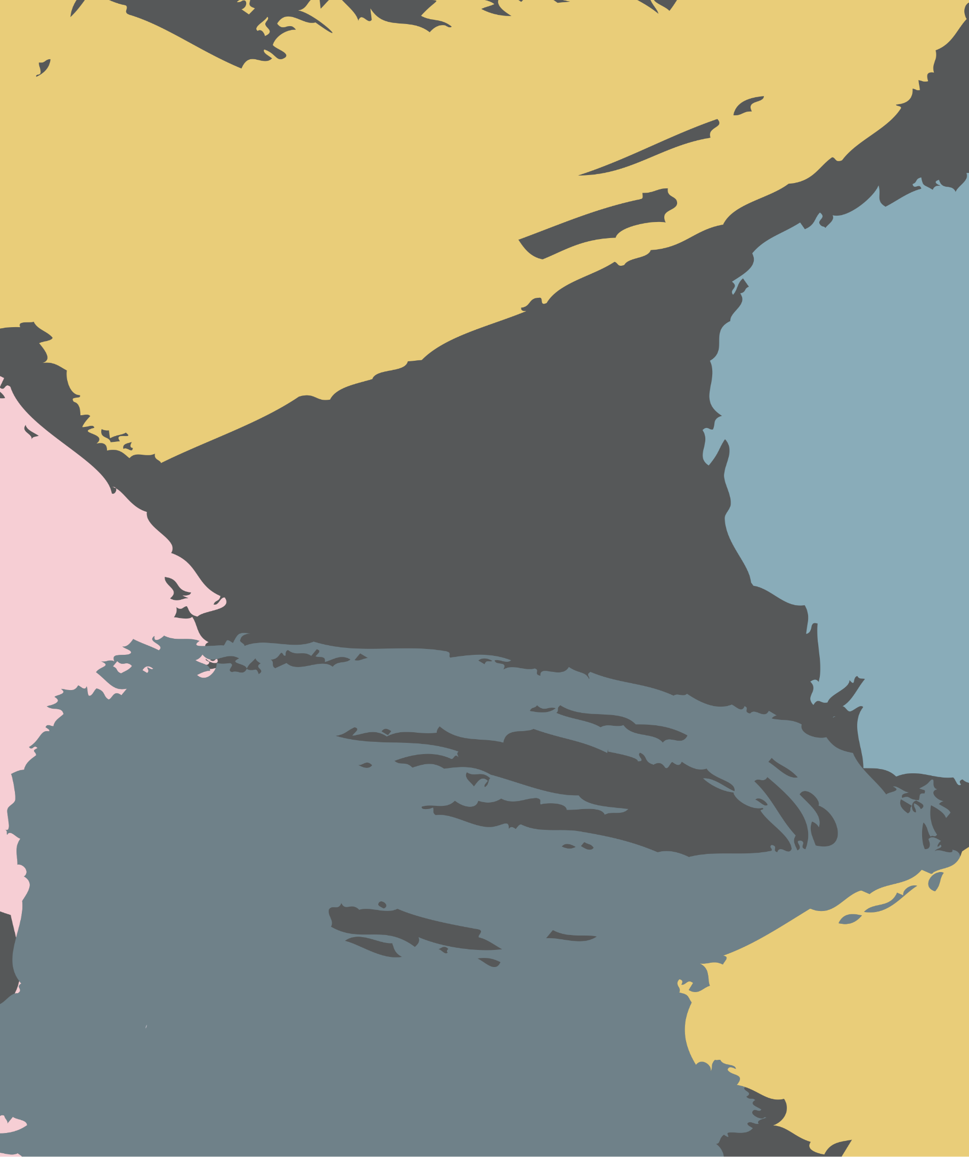

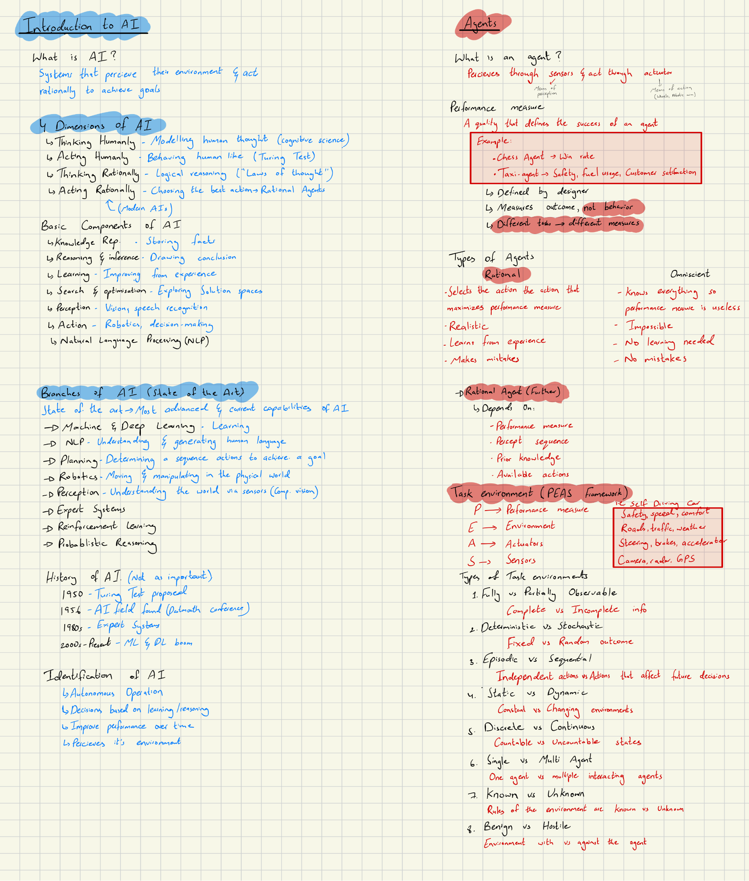fs

f

sf

sf

[](file:///C:\Users\tgond\Downloads\AI%20Images%20Week%202\Astarpathfinding.gif)[](file:///C:\Users\tgond\Downloads\AI%20Images%20Week%202\X7rvS7Kbgc-dijkstra_animation.gif)[](file:///C:\Users\tgond\Downloads\AI%20Images%20Week%202\1_sbUuCeAb1EHgYBszGOXSWg.gif)[](file:///C:\Users\tgond\Downloads\AI%20Images%20Week%202\1_qG4-VA4dmMNHu9Kafat30g.gif)[](file:///C:\Users\tgond\Downloads\AI%20Images%20Week%202\Bidirectional%201.gif)[](file:///C:\Users\tgond\Downloads\AI%20Images%20Week%202\1_GT9oSo0agIeIj6nTg3jFEA.gif)